

PROJECT AND TEAM INFORMATION

Project Title
(Try to choose a catchy title. Max 20 words).

TypeMaster: A Comprehensive Typing Tutor with Real-Time Feedback and Progress Tracking

Student/Team Information

Team Name:  Team # (Mentor needs to assign) | Alpha Achivers
Team member 1 (Team Lead)  (Last Name, name: student ID: email, picture): | Aggarwal, Harsh -2471181  harshgrwl18@gmail.com  
Team member 2  (Last Name, name: student ID: email, picture): | Khanduri , Anubhav- 24711276  anubhavkhanduri112@gmail.com  
Team member 3  (Last Name, name: student ID: email, picture): | Rajwar, Ronit- 24711373  Ronitrajwar03@gmail.com  
Team member 4  (Last Name, name: student ID: email, picture): | Kanyal, Dipanshu- 24711115  kanyal.dipanshu7351@gmail.com  

PROJECT PROGRESS DESCRIPTION (35 pts)

Project Abstract (2 pts)
(Brief restatement of your project’s main goal. Max 300 words).
Our project is a basic typing tutor application developed in C. It helps users improve their typing speed and accuracy through random word generation and real-time input tracking.
The goal is to :
- Provide an interactive learning tool that displays words,
- Checks user input,
- Measures performance based on time and accuracy.

Updated Project Approach and Architecture (2 pts)
(Describe your current approach, including system design, communication protocols, libraries used, etc. Max 300 words).
We are building the system using the C programming language, structured with functions for random word generation, input capture, score calculation, and file operations. The system uses libraries such as stdio.h, stdlib.h, time.h, and conio.h
The typing flow is handled in a loop, displaying one word at a time and accepting user input through getch() and _kbhit() for responsiveness.
The architecture is modular, with clear separation between display, logic, and input components.

Tasks Completed (7 pts)
(Describe the main tasks that have been assigned and already completed. Max 250 words).
Task Completed | Team Member
- basic Ui feature like system(cls)  - Real time input track with getch _kbhit  - Accuracy Checking Logic  - Stats Display  - User Data Management  - Word Search Tree Management  - User Deletion | Harsh Aggarwal  Harsh Aggarwal  Ronit  Anubhav  Harsh & Ronit  Harsh Aggarwal  Harsh And Dipanshu

Challenges/Roadblocks (7 pts)
(Describe the challenges that you have faced or are facing so far and how you plan to solve them. Max 300 words).
- Cross-platform Issues: system("cls") and system("pause") work only on Windows. We handled this with preprocessor directives.
- Random Word Repeats: Initially, random words kept repeating. Solved by seeding srand(time(NULL)).
- Real-time Input Lag: Standard input functions caused delays; solved with _kbhit() and getch().
- Typing Timer: Measuring time accurately during input was tricky. Used clock() for better results.
- Backspace Handling: Managing deletion of typed characters without crashing needed extra checks.
- Score Calculation Bugs: Incorrect word matching logic initially gave wrong scores; fixed with string comparison.
- Team Coordination: Working across devices caused merge conflicts, later solved with Physical Coordinating at university Library

Tasks Pending (7 pts)
(Describe the main tasks that you still need to complete. Max 250 words).
Task Pending | Team Member (to complete the task)
Word Race Segment has time Based infinite Loop issue  Empty String User Registration issue  Practice Game Sentence Looping issue time Based  Testing of complete Working | Anubhav  Anubhav  Harsh and Dipanshu  Ronit

Project Outcome/Deliverables (2 pts)
(Describe what are the key outcomes / deliverables of the project. Max 200 words).
The final deliverable will be a working typing tutor application in C
capable of
- Generating words,
- Timing user input,
- Calculating accuracy
- Saving results.

Progress Overview (2 pts)
(Summarize how much of the project is done, what's behind schedule, what's ahead of schedule. Max 200 words.)
About 75% of the project is complete. Word generation, input capture, and scoring systems are implemented. Final tasks like file saving and polishing the UI are still in progress.
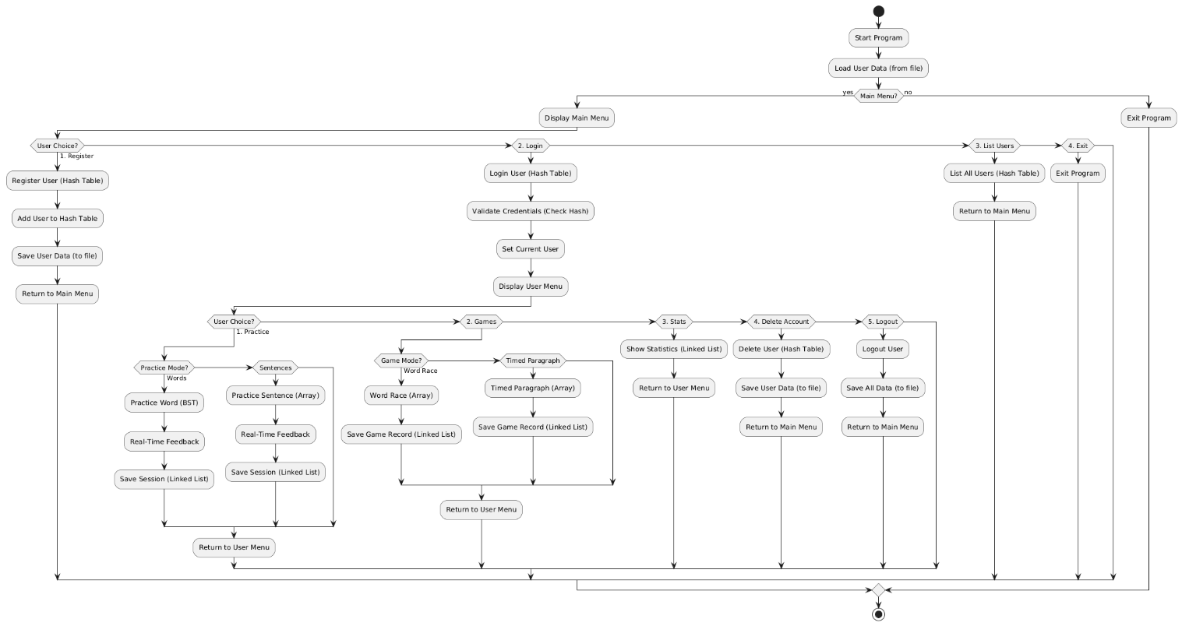

Codebase Information (2 pts)
(Repository link, branch, and information about important commits.)
Repository: https://github.com/HarshAggarwal18/Typing-Tutor
Branch : main
Harsh
Dipanshu
Ronit
Anubhav
Important Commit: delete-User-Data added : Deletion of User Record From Fetched File
HashMap Bit Manipulation : Bit mapping of user into Hash Table
Practice Sentence Added : Practice Sentence with keyBoard Display

Testing and Validation Status (2 pts)
(Provide information about any tests conducted)
Test Type | Status (Pass/Fail) | Notes
 | Pass  Pass  In Progress | Words generated without repeat  Timing and word count calculated  Accuracy not 100% consistent yet
  Word Test
  Input Speed test
  Accuracy Tracking

Deliverables Progress (2 pts)
(Summarize the current status of all key project deliverables mentioned earlier. Indicate whether each deliverable is completed, in progress, or pending.)
Deliverable | Status
Word Serach Tree | Completed
Input Tracking & Timer | Completed
Accuracy/Score System | Completed
File Save Feature | In Progress
Final UI & End Summary | Pending

